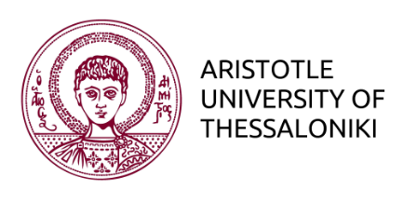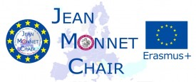

EUROPEAN INTEGRATION JOURNALISM

SCHOOL OF JOURNALISM AND MASS COMMUNICATION
MA in Digital Media, Communication & Journalism
Pathway 2: European Journalism
Research Seminar: Reporting Europe
Christos Frangonikolopoulos
assoc. Professor International Relations
& Jean Monnet Chair European Integration Journalism
https://auth.academia.edu/ChristosFrangonikolopoulos
http://jeanmonnetchair.jour.auth.gr
Email: chfragk@jour.auth.gr

This course wishes to encourage students to work/research on several important political, economic, societal and global dimensions/challenges of Europe, which not only occupy a central position in the agenda of European Journalism, but also affect the formation of public attitudes towards European integration. Students will work on research projects in small groups. In so doing, they will not only have to develop the plan, methodology and organization of the projects themselves, but will also to present their research (during the term) and submit investigative reports (at the end of the term). The objective of this form of work and evaluation is twofold:

- that students enrich their knowledge about the economic, social, political and global contexts of Europe/European Union, and in so doing improve their analytical skills and insight by researching and scrutinizing a problem/challenge of the EU
- that write investigative reports reflecting a critical and analytical ‘European perspective’

Areas of investigation and research:

- Defence and Security Policy of the EU – Motives: Geopolitics and Competing Priorities, Emergent Powers China, Problematic Transatlantic relations, Russian ‘hostility’, Terrorism, Refugees – Challenges & Problems: national priorities, economic difficulties etc (Haenchen, Migkos, Alexandrou)
- The Integration of Refugees/Immigrants – Why? (a) Increasing and continuing trend (b) Debate within Europe: how effective is multiculturalism, xenophobia etc. How to integrate? (Akilidis, Chelidonis, Giourouki)
- EU Russian relations: security, trade, bilateral agreements, political influence, disinformation and ‘fake news’ (Morton, Smilianis)
- Climate and Energy Security, sustainable growth (Pantelakis)

- Until the beginning of May discussions/research
- Presentations 8 May, 15 May, 22 May, 29 May
- Mid-June Submission of Investigative Report

