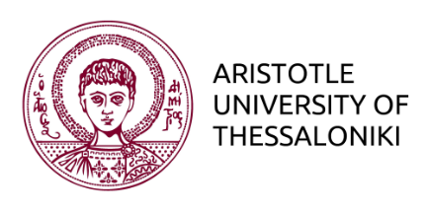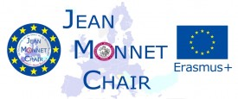
European Integration Journalism
SCHOOL OF JOURNALISM AND MASS COMMUNICATION
MA in Digital Media, Communication & Journalism
Pathway 2: European Journalism

DIVERSITY AND MEDIA IN EUROPE
https://www.facebook.com/groups/1278811112154585/

Christos Frangonikolopoulos
assoc. Professor International Relations
& Jean Monnet Chair European Integration Journalism
https://auth.academia.edu/ChristosFrangonikolopoulos
http://jeanmonnetchair.jour.auth.gr
Email: chfragk@jour.auth.gr

Class Discussion and Presentations

(1) Cultural Diversity in the EU today
- Risks / threats today (rising intolerance, support for xenophobic parties, religious freedom vs expression, economic difficulties, immigration, distorted images and stereotypes by the media etc.)

The refugee crisis has highlighted a historical fact: Europe’s cultural, ethnic and religious diversity will increase in a transformative way in the years and decades to come.
Given this reality how has the debate on multiculturalism changed and how can we open a more healthy and productive debate about our ‘collective” identity?
Think of what is meant by the concept of cultural diversity and what has the EU done in this direction, and especially in terms of religion, ethnicity, race and migration?

(2) Social Diversity in the EU today
- ways in which European policies have dealt with gender, sexuality, age and disability
- how issues linked to these various sources of social diversity have succeeded or failed to become stable features of European institutions’ declarations and practices

Think of what is meant by the concept of social diversity and analyse what the EU is actually doing in this direction. Is it only rhetoric, driven by considerations of political convenience, or are real measures being taken? And do they make a difference?

(3) Media and diversity: the role of journalism
- Freedom and media pluralism
- Media narratives on tolerance and difference
Think of how our understanding of diversity and difference has impacted on the way in which media models, institutions and professionals engage with social and cultural diversity. In so doing focus on different national media policy frameworks, economic models and media cultures. Examines and compare media content across the EU and their responses to cultural and social diversity.

(4) Reporting diversity inclusiveness in EU
- Recommendations/best practices
- Case Studies
Examine and discuss ways of improving journalism practice in order to bridge social and cultural divisions. In so doing analyse the responsibility, and power of journalism in reporting these diversity issues.

Final Project
Work and submit an in-depth investigative project, which involves researching, compiling and presenting your own TV or radio documentary, website or print journalism work, together with a self-reflective, critical analysis (5000 words) that will demonstrate what you have learned during the course.

