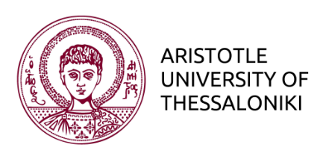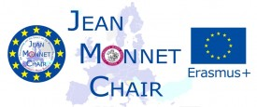

EUROPEAN INTEGRATION JOURNALISM

SCHOOL OF JOURNALISM AND MASS COMMUNICATION
MA in Digital Media, Communication & Journalism
Pathway 2: European Journalism

Research Seminar: Reporting Europe

Spring Semester 2016-17

Wednesday 17:00 – 19:30
Room 2a, Floor 2, Egnatias 46 Building

Course Instructor:
Christos Frangonikolopoulos
assoc. Professor International Relations
& Jean Monnet Chair European Integration Journalism
https://auth.academia.edu/ChristosFrangonikolopoulos
Office: Floor 1, Egnatias 46 Building
Email: chfragk@jour.auth.gr

Office Hours: Wednesday: 15:00 -17:00
Office tel.: +302310-992072

This course wishes to encourage students to work on several important political, economic, societal and global dimensions/challenges of Europe, which not only occupy a central position in the agenda of European Journalism, but also affect the formation of public attitudes towards European integration.

The challenges/problems that students will work on are:

- Economy/debt crisis
- Refugee/Migration Crisis
- Brexit
- Populism/Nationalism
- Geopolitical changes/risks
- Terrorism
- Civil-military cooperation in refugee camps + election results Holland and France

Students will work on research projects in small groups.

In so doing, they will not only have to develop the plan, methodology, bibliographical sources and organization of the projects themselves, but will also be expected to present (during the term) and submit project/journalistic articles/reports (at the end of the term).

The objective of this form of work and evaluation is twofold:

- that students enrich their knowledge about the economic, social, political and global contexts of Europe/European Union, and in so doing improve their analytical skills and insight by researching and scrutinizing a problem/challenge of the EU
- To write projects/articles reflecting a critical and analytical ‘European perspective’

Working Plan:

Lectures
- 1st week: Current Challenges of the EU
- 2nd week: Prospects of the EU

Group Presentations
- 3rd week: Economy/debt crisis
- 4th week: Brexit
- 5th week: Populism/Nationalism
- 6th week: Geopolitical changes/risks
- 7th week: Terrorism

Guest Speaker
8th week: to be arranged

Develop/ Create an on-line blog, that concentrates on critical research of the EU, European Integration and contemporary internal/ external challenges/problems.
- Weeks 9-13

