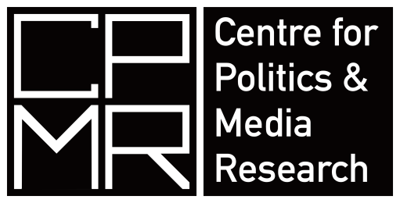
Politics in a post-truth era
10th – 11th July 2017
EB302, Executive Business Centre, Bournemouth University
Overview
The concept of post-truth, where facts are deemed less important than beliefs, is one that has recently been frequently invoked when making sense of the modern political campaigning environment. The suggestion is that political campaigns exploit and reinforce strongly held beliefs, encouraging the disavowal of contrasting facts, in order to undermine support for the arguments of opponents.
Post-truth has become most associated with campaigns that invoke more populist arguments. Such arguments give voice to privately held beliefs, often hidden by norms of societies which reinforce pejorative stereotypes based on religious and racial differences, gendering of roles and discussing myths of us (as a nation and people) and the others whose differences mark them as not us. Hence there are far-reaching implications of such practices for democratic societies.
The workshop will explore the underlying themes and implications of this phenomenon including: Is post truth really new, What does a post-truth campaign look like, Why might beliefs influencing voting behaviour over logic and reason, How does post-truth link to the marketisation and professionalization of campaigning, What does post-truth tell us about the current and future state of democratic engagement and of democracy itself.
Information for speakers
Speakers should speak for 15 minutes leaving a further 15 minutes for discussion. Further discussion can take place over coffee and dinner
Location
The venue is 5/10 minutes walk from Bournemouth train station (where buses and coaches also arrive).
The full address is: 89 Holdenhurst Rd, Bournemouth BH8 8EB
Hotel information can be found at: http://bournemouth.co.uk/where-to-stay/
10th July
12 noon – arrival, registration and coffee – do bring a sandwich
12.30 Introductions and opening statements: Dr Darren Lilleker
1.00 Panel: Understanding Post Truth
Barry Richards: The psychological underpinnings of the post-truth period
Anastasia Deligiaouri: Discursive Construction of Truth, Ideology and Post Truth Narrations in Contemporary Politics
Richard Scullion: Democracy in a de-civilising age
2.30 Break
3.00: Panel: The history and practice of post-truth
TBA
Ruth Garland: Is post-truth just another word for political spin or a radical departure from it? Evidence from behind the scenes in UK government communications: 1997 to 2014
4.00: Roundtable: Post-truth, social inequality and marginalisation
Participants: Deborah Gabriel (Bournemouth University); Melanie Klinkner (Bournemouth University); Maria Norris (London School of Economics); Alina Thiemann (Institute of Sociology, Romanian Academy)
Chair: Darren Lilleker
5.00: Close
6.30pm Workshop Dinner at Spice of Lahore http://spiceoflahore.co.uk/
__________________________________________________________________________________
WORKSHOP DINNER
We have arranged a starter and main course which is covered by the PSA Political Marketing Group and the Centre for Politics and Media Research.
Spice of Lahore does not serve alcohol, if you would like to bring wine or beer you are very welcome
__________________________________________________________________________________

11th July
9.00: Arrival and coffee
9.30: Panel: Post-truth and the media
Stamatis Poulakidakos, Anastasia Veneti & Christos Frangonikolopoulos: There and back again: Post-truth, post-propaganda or just…propaganda?
Susana Salgado: Online media impact on politics: A post-postmodernism era or a post-truth era?
Daniel Jackson: The Chaos of News
11.00: Break
11.30: Roundtable: Post-truth and fake news, reflections on recent elections and referenda
Participants: Darren Lilleker (Bournemouth University); Elena Afromeeva (University of Jena); Daniel Jackson (Bournemouth University); Susana Salgado (University of Lisbon)
Chair: Anna Feigenbaum

12.30: Close and future plans
__________________________________________________________________________________
Publication
The longer-term aim is to develop an edited collection of work that would include solo-authored or joint publications from participants that address these questions. The volume will be published in the Palgrave series Political Campaigning and Communication.
__________________________________________________________________________________

